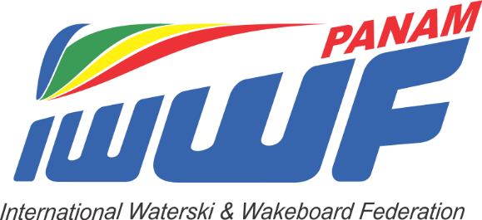

President Secretary General
Jeffry Armstrong Karen McClintock
621 Gulf Shore Drive 14 Chatsworth Crescent
Destin, FL 32541 Ottawa, Ontario CAN K1V 9Z1
jeffryaski@aol.com karen@karenmcclintock.com
+1 662-417-5333 +1 613-294-1945

August 30, 2020

PRELIMINARY NOTICE OF 2020 CONGRESS of the
PAN AMERICAN CONFEDERATION of the IWWF

Dear Member Federations and Presidents:
Please be advised that, as unanimously voted by the Presidents of Pan Am Federations, the Congress of the Pan-American Water Ski Confederation will take place with a Zoom meeting starting at 4pm CST on Thursday, November 19, 2020. Delegate appointment forms will be emailed very soon.
The Pan-American Water Ski Championships are scheduled for 2021 but the location and dates are yet to be determined.
Call for Agenda Items:
You are invited to submit any items of business for addition to the agenda for discussion or decision at this meeting so that they may be included in the Agenda. The deadline for Agenda items you may have is October 11, 2020. Any items not received by the President or Secretary General by this date will require unanimous approval by the Congress to be allowed placement on the agenda at the meeting.
Call for Nominations:
This Congress will include an election of new Officers (President, Secretary-General, and Vice-President). Nominations should be submitted to the President or Secretary General and should include a letter of support from your Federation. A CV is also recommended. Please submit nominations by October 11, 2020.
Call for Bids:
If your Federation is considering hosting a future Pan-American Championship Tournament (all disciplines), please prepare and submit bids by October 11, 2020. Bids should be prepared in writing for distribution to members for their consideration before this meeting. Bids should include as much information as possible, including a proposed budget. A copy of the List of Obligations and Agreement is available at any time from the President.
2020 Federation Dues:
Please also note these important points:
1. Federations must have paid all their subscriptions/dues in full to have the right to participate and vote at this important meeting.
2. Federations must have paid all their subscriptions/dues in full to have the right to participate in the 2020 Pan-American Water Ski Championships.
Thank you and I look forward to meeting with you all very soon. If you have questions, please let me know.
Jeffry

