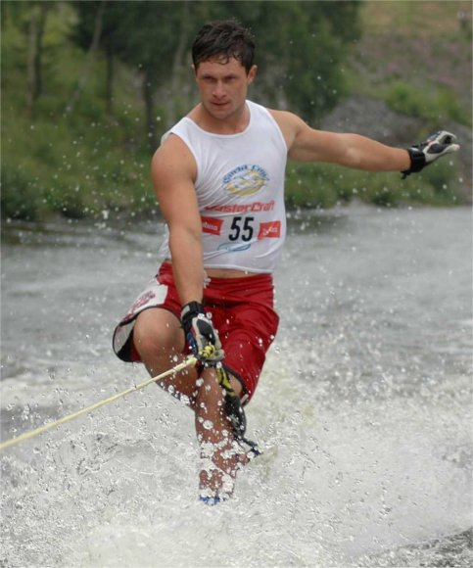**TOURNAMENT**

2014 Water Skiers of the Year

**Aliaksei Zharnasek - BLR**



Current world trick record holder 12570 points

Current E&A trick record holder 12570 points

2014 IWWF Experimental Dynamic World Ranking List Open men tricks -1st;

2014 Elite Ranking List men tricks - 1st

2014 Europe - Africa Confederation Ranking list Open Men tricks - 1st

2014 E&A Open Championships - 1st place in tricks

2014 US Masters 2nd place

2014 US Open 1st place

2014 Dutch Masters Shortboard 2nd place

Aliaksei Zharnasek, current World Record holder and 3-times tricks World Champion (2009, 2011, 2013), this year confirmed his leading position not just in Europe, but also in the World. He won the gold medal in tricks at the E&A Championships and ranked number one in tricks on the Europe & Africa, World and Elite World Ranking Lists. This high World ranking placement has put him ahead of the other winners from the European Championships.

His style of skiing is unique being both precise and powerful at the same time. With the videos which he posts on Facebook and Youtube, he shows how cool trick skiing can be.

**Erika Lang – USA**

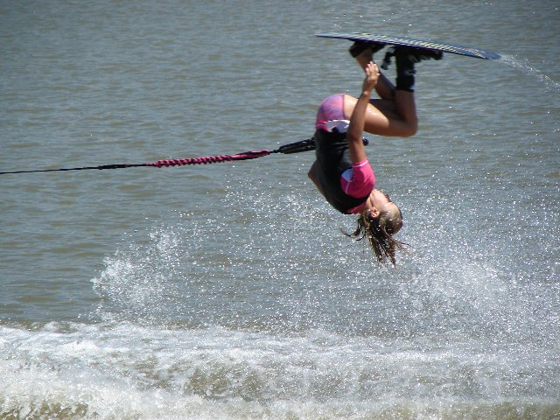

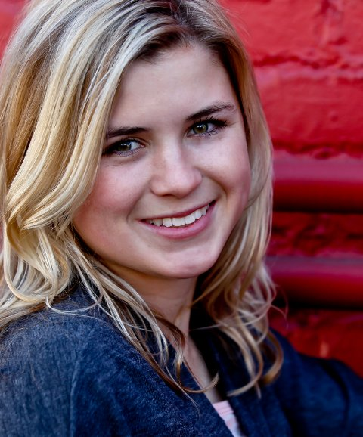

Current world trick record holder 10460 points

2014 IWWF Experimental Dynamic World Ranking List Open Women tricks -1st;

2014 Elite Ranking List women tricks - 1st

2014 Pan American Championships Tricks – 1st place

2014 US Masters 1st place

2014 US Open 1st place

2014 Moomba Masters 1st place

Erika has used her gymnastics background to catapult herself to the top of the elite women trick skiers list. Erika is the current reigning World Champion having won in Chile in 2013. She broke the World Record twice in 2014 holding the current World Record of 10460. Erika skied in eight Record/Elite tournaments in 2014 and placed 1st in all of them.