RACING COUNCIL ATHLETES OF THE YEAR 2014

MALE
Dave Vansteelant BEL
Winner, 2014 European Championships--Open Men
Winner, 2014 Europe Cup--Open Men
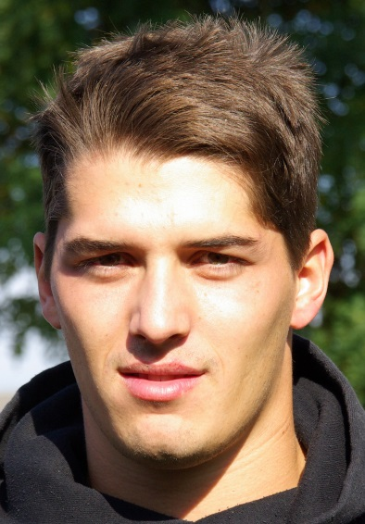
Winner, 2014 Diamond Race--Open Men
Winner, 2014 Belgian Championships--Open Men
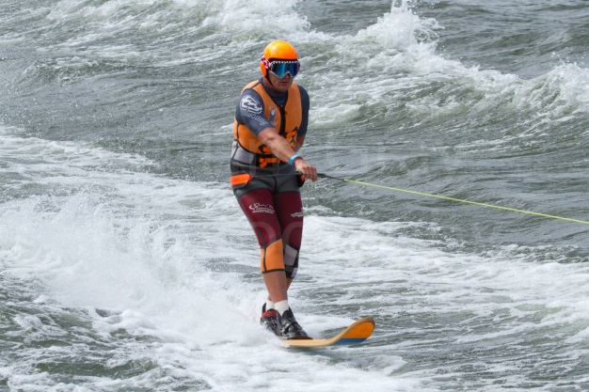

FEMALE
Ellen Jones AUS
Winner, 2014 Australia Championships--Open Women
Winner, 2014 Catalina Ski Race--Open Women
Winner, 2014 Bridge to Bridge Water Ski Classic--Open Women

