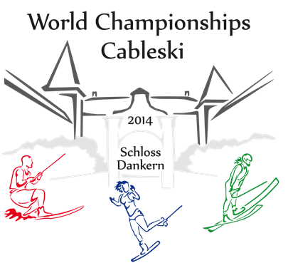

24th September – 27th September 2014

Intention To Enter

The ……………………..federation intend to participate in the World Cable SKI Championships 2014

Our Team will consist of:

Category / Sex | Women (Number of People) | Men (Number of People)
Open
Officials

Contact Details for Future Information on this Championship
Name
Function
Address
Telephone no. home
Telephone no. mobile
Fax no.
Email address

Please send this intention to enter before 27th July 2014 via Email to:

Netherlands Waterski & Wakeboard Bond (NWWB)
Joost de Leijer (ekcableski@nwwb.nl and to :
IWWF World Cableski Council Chairman , Marie-Anne Persoons
marie-anne.persoons@h2oski.be

