**Cableski Female athlete of the year - 2013**

**Irina Dimont - Belarus**

Irina has to be seen as a great athlete, with the spirit of ‘never give up’. After a series of injuries, which prevented her from becoming one of the great Belarus female water ski athletes, earlier, at the age of 24 years, Irina proved this year that she is really a great skier. With her, we finally have a new athlete at the top of the women Cableski group, being able to meet with the best in all three events.

At the E&A Cableski Open Championships, Irina managed to get a spot on each possible podia. She took the **Gold** medal with the Belarus team. She became second, taking the **Silver** medal in **Slalom**, **Tricks** and **Overall** and took **Bronze** in Jump.

In addition to this, she took the Belarus Open Women Cableski Slalom Champion, title also home.

Proving that she is indeed a very good skier and has a good regularity, Irina ended the 2013 season, ranked on the World and E&A Cableski Ranking List; fourth in Slalom and Tricks, fifth in Jump, third in Overall.

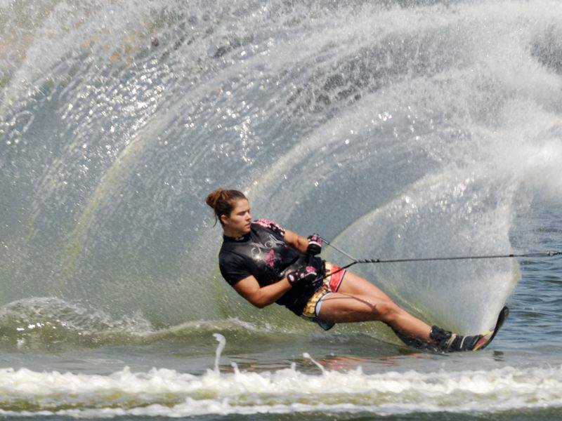 

|  |  |  |
| --- | --- | --- |
|  |  |  |

E&A Cableski Champion team – Belarus

Silver in Slalom, Tricks and Overall

Bronze in Jump

Open Women Cableski Slalom Champion in Belarus