CABLESKI ATHLETES OF THE YEAR 2014

Female athlete of the year - 2014
Joulia Meier Gromyko - Belarus

Joulia Meier Gromyko has been at the top of Cableski for years, she is not just a brilliant skier, she is also a very good coach. Last year we had the impression the she was coming to a point where she was going to change from mainly skier to mainly coach, but this was not correct. This year Joulia just showed her fellow competitors that she is still as fit as one can be.
The first week in Schloss Dankern was the week of the E&A Junior and Senior Championships and no other senior female skier was able to come anywhere close to Joulia’s results. So the four titles in the E&A Seniors were done. BUT Joulia saw this more as an extra training opportunity for the Cableski Worlds taking place at the same cable, just one week later. And the training gave the desired results…
Joulia took the Cableski World title in tricks and overall and became second in jump.
Then there was the World Cup, the cable in Schloss Dankern is known to be a great cable for jumping, hence the new record set by Alexander Vasko in men jumping, but Joulia was not able to break the Cableski World Record in Schloss Dankern. As a result, she was very eager to do this at the World Cup in Shanghai, but Iryna Tourets also wanted the new record. Iryna broke it first with 48.9 m, but two jumps later, on her third jump Joulia just equaled the new record and became co-record holder.
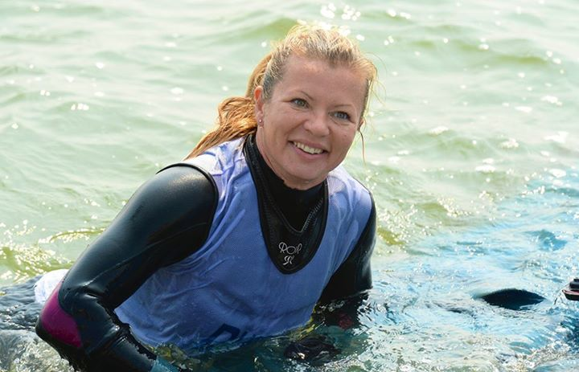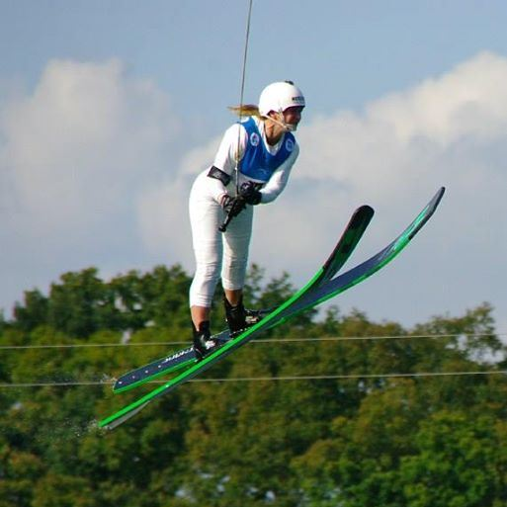

World Cableski Champion team – Belarus
Gold in Tricks and Overall
Silver in Jump
Cableski Ranking List, first in tricks, jump and over, 5th in slalom

Cableski Male athlete of the year – 2014
Alexander Vasko – Slovak Republic

Alexander Vasko is only 20 years old and is one of the top Cableski skiers, but this year was extremely good for him. The climax of the year for him was the Cableski World Championships. In the preliminary round he broke the 9 year old Cableski World Jump record from Thomas Bauer (63.8m), with an incredible jump of 64.2 meter. This record set the pace for the jump finals and the skiers went for it with a thriller of the finals as a result. Still Alexander proved he is the best jumper this year winning the World title in addition of his new World Record.
But Alexander is not only a great jumper, he is just a very good overall skier. At the Cableski Worlds in addition to the gold medal in jumping, he also took silver in tricks and bronze in overall.
On the Cableski Ranking List he is first in jump and overall and places fourth in tricks and fifth in slalom.

In addition to the World Championships, Alexander placed second in jump at the First Cableski World Cup in Shanghai - China, with only Nikita Papakul being able to beat Alexander. At the grand prix of cable in Asten, Austria Alexander ended first in jump, and second in tricks, behind a topper like Ilya Labkovic, and in slalom, after the almost unbeatable Nadav Ativ, just once again a proof of his great shape this year and his skills as a great overall skier.

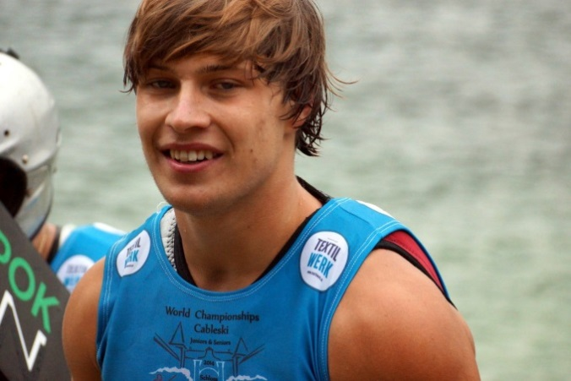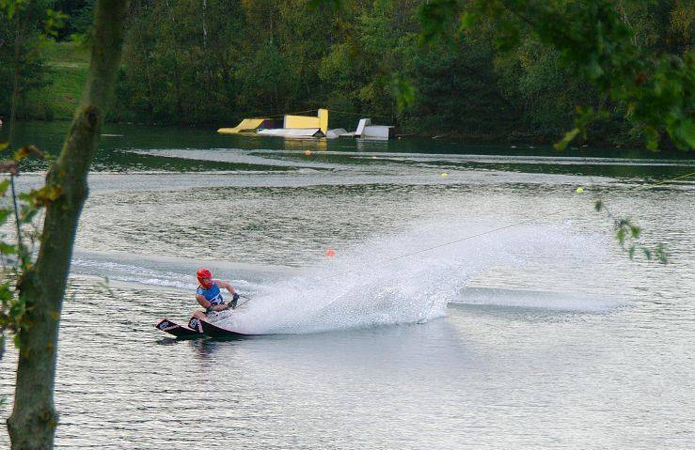

World Champion Jump
New World record with 64.2 m
First E&A Ranking List jump
First World Ranking List jump
Open Men Slovak tricks, jump and overall Champion (slalom second)

