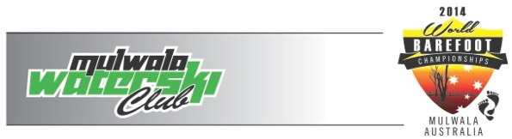
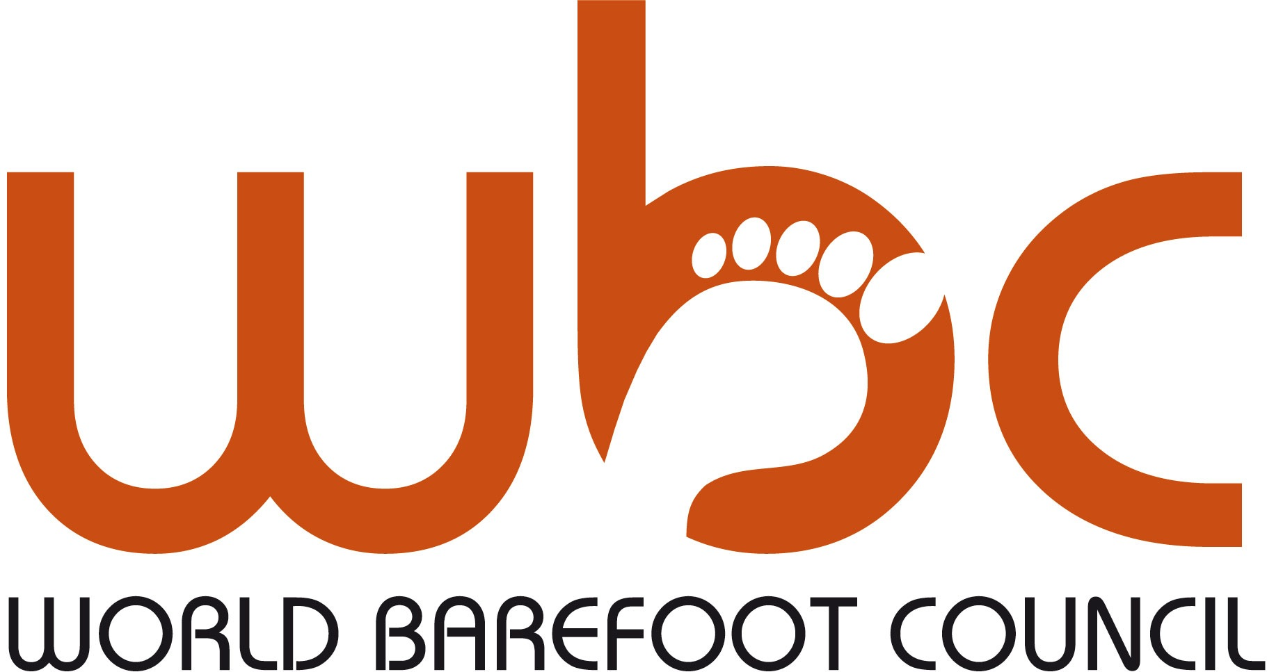
2014 World Barefoot Water Ski Championships
March 11-16th
Mulwala, NSW, Australian
DEFINITIVE ENTRY FORM COVER PAGE

The ______________________ Federation has sent the entry forms of the following skiers to the organiser of the above titled event (please write in capital letters):
* Add rows to this form as necessary.

Contact Person: email:

Family Name | First Name | Sex | Jr/Snr/Open | Date of Birth
Return the forms to the Secretary of the Organising Committee, Confederation Barefoot Council Chairman, and the WBC Chairman
at least 4 weeks prior to the start of competition. Deadline: 1/2/14
LOC: skiproshop@me.com
WBC Chairman: Richard Gray g1footer@aol.com

Any Federation not meeting these requirements will not be allowed to compete until the Federation pays to the WBC a fine of $10 (USD) per skier per day after the four week deadline, for each skier not officially entered.

Doping control
In accordance with the IWWF Anti-Doping Rules, drug controls will be conducted during this competition. In entering this competition all riders agree to be subject to doping control. Information about the IWWF Anti-Doping programme can be found at: http://www.iwsf.com/AntiDoping/2013%20WEBpageinformation.htm where there are also links to the list of banned substances.

