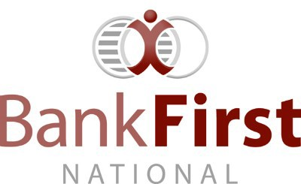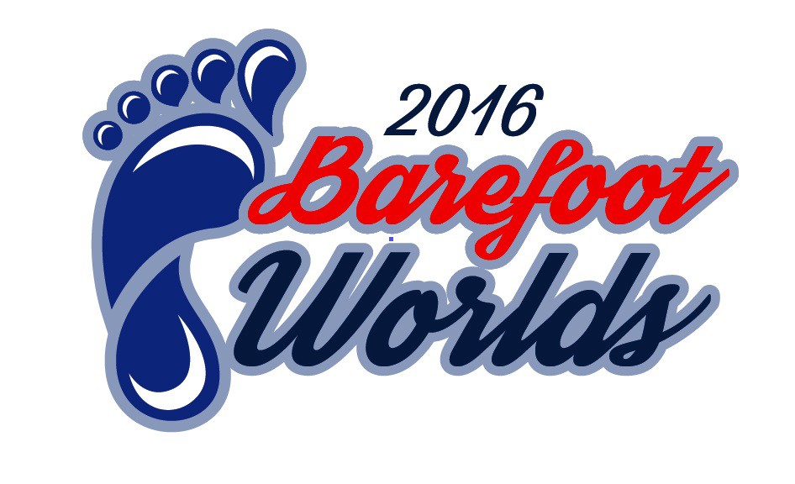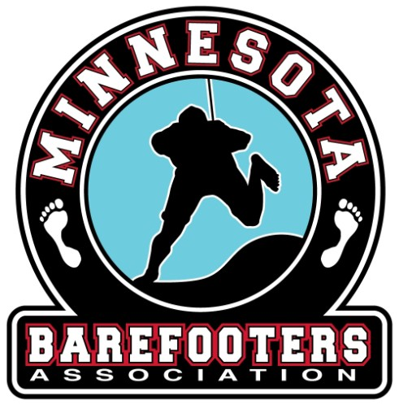

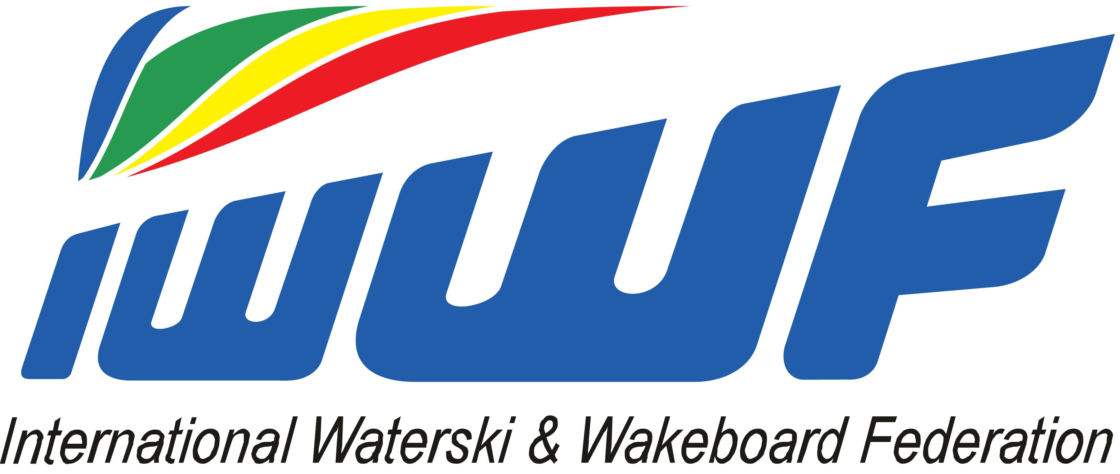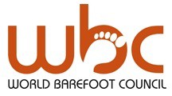2016 World Barefoot Water Ski Championships
presented by Bank First
August 13-20 Alma Center, WI USA

DEFINITIVE ENTRY FORM COVER PAGE
* Use Page 2 of this document as necessary.
Family Name | First Name | Sex | Jr/Snr/Open | Date of Birth

Contact Person email:
Contact Person 2:
email
Return the forms to the Local Organizing Committee Registrar, Confederation Barefoot Council Chairman, and the WBC Chairman at least 4 weeks prior to the start of competition. Deadline is July 17th, 2016.

LOC Registrar: Doug Bohn
registrar@mnbarefooters.org

Any Federation not meeting these requirements will not be allowed to compete until the Federation pays to the WBC a fine of $10 (USD) per skier per day after the four week deadline, for each skier not officially entered.

Doping control
In accordance with the IWWF anti-Doping Rules, Doping controls will be conducted during the competition. By entering this competition, all athletes agree to be subject to doping control.
Information about the IWWF Anti-Doping program, the current IWWF AD Rules and links to the list of banned substances can be found on http://www.iwwfed.com/ by clicking the Anti-Doping Information link at the top of the menu on the left sidebar of the homepage.

2016 World Barefoot Water Ski Championships
presented by Bank First
August 13-20 Alma Center, WI USA
DEFINITIVE ENTRY FORM COVER PAGE 2

Family Name | First Name | Sex | Jr/Snr/Open | Date of Birth

