TABLE OF CONTENTS
International Waterski & Wakeboard Federation
Disabled Council

Competition Handbook
Water Ski for the Disabled
Addendum
Classification Appendices
Issued by the Disabled Council
**January 1, 2011**

Appendix A – MP Testing Form - 6/00 - 1/08 3
Appendix B – A/L Testing Form - 4/01- 1/08 4
Appendix C – V Testing Form - 4/01 - 1/08 5
Appendix D – MP Familiarisation Guidelines Form - 6/00 6
Appendix E – Testing Board Diagram - 6/00 7
Appendix F1 – The Skeletal System - 6/00 8
Appendix F2 – The Dermatomes of the Body - 6/00 9
Appendix F3 – Functional Activity for Spinal Cord Injuries - 6/00 10
Appendix G – Cross Section of the Human Eye/
Light Transmission to the Brain - 6/00 11

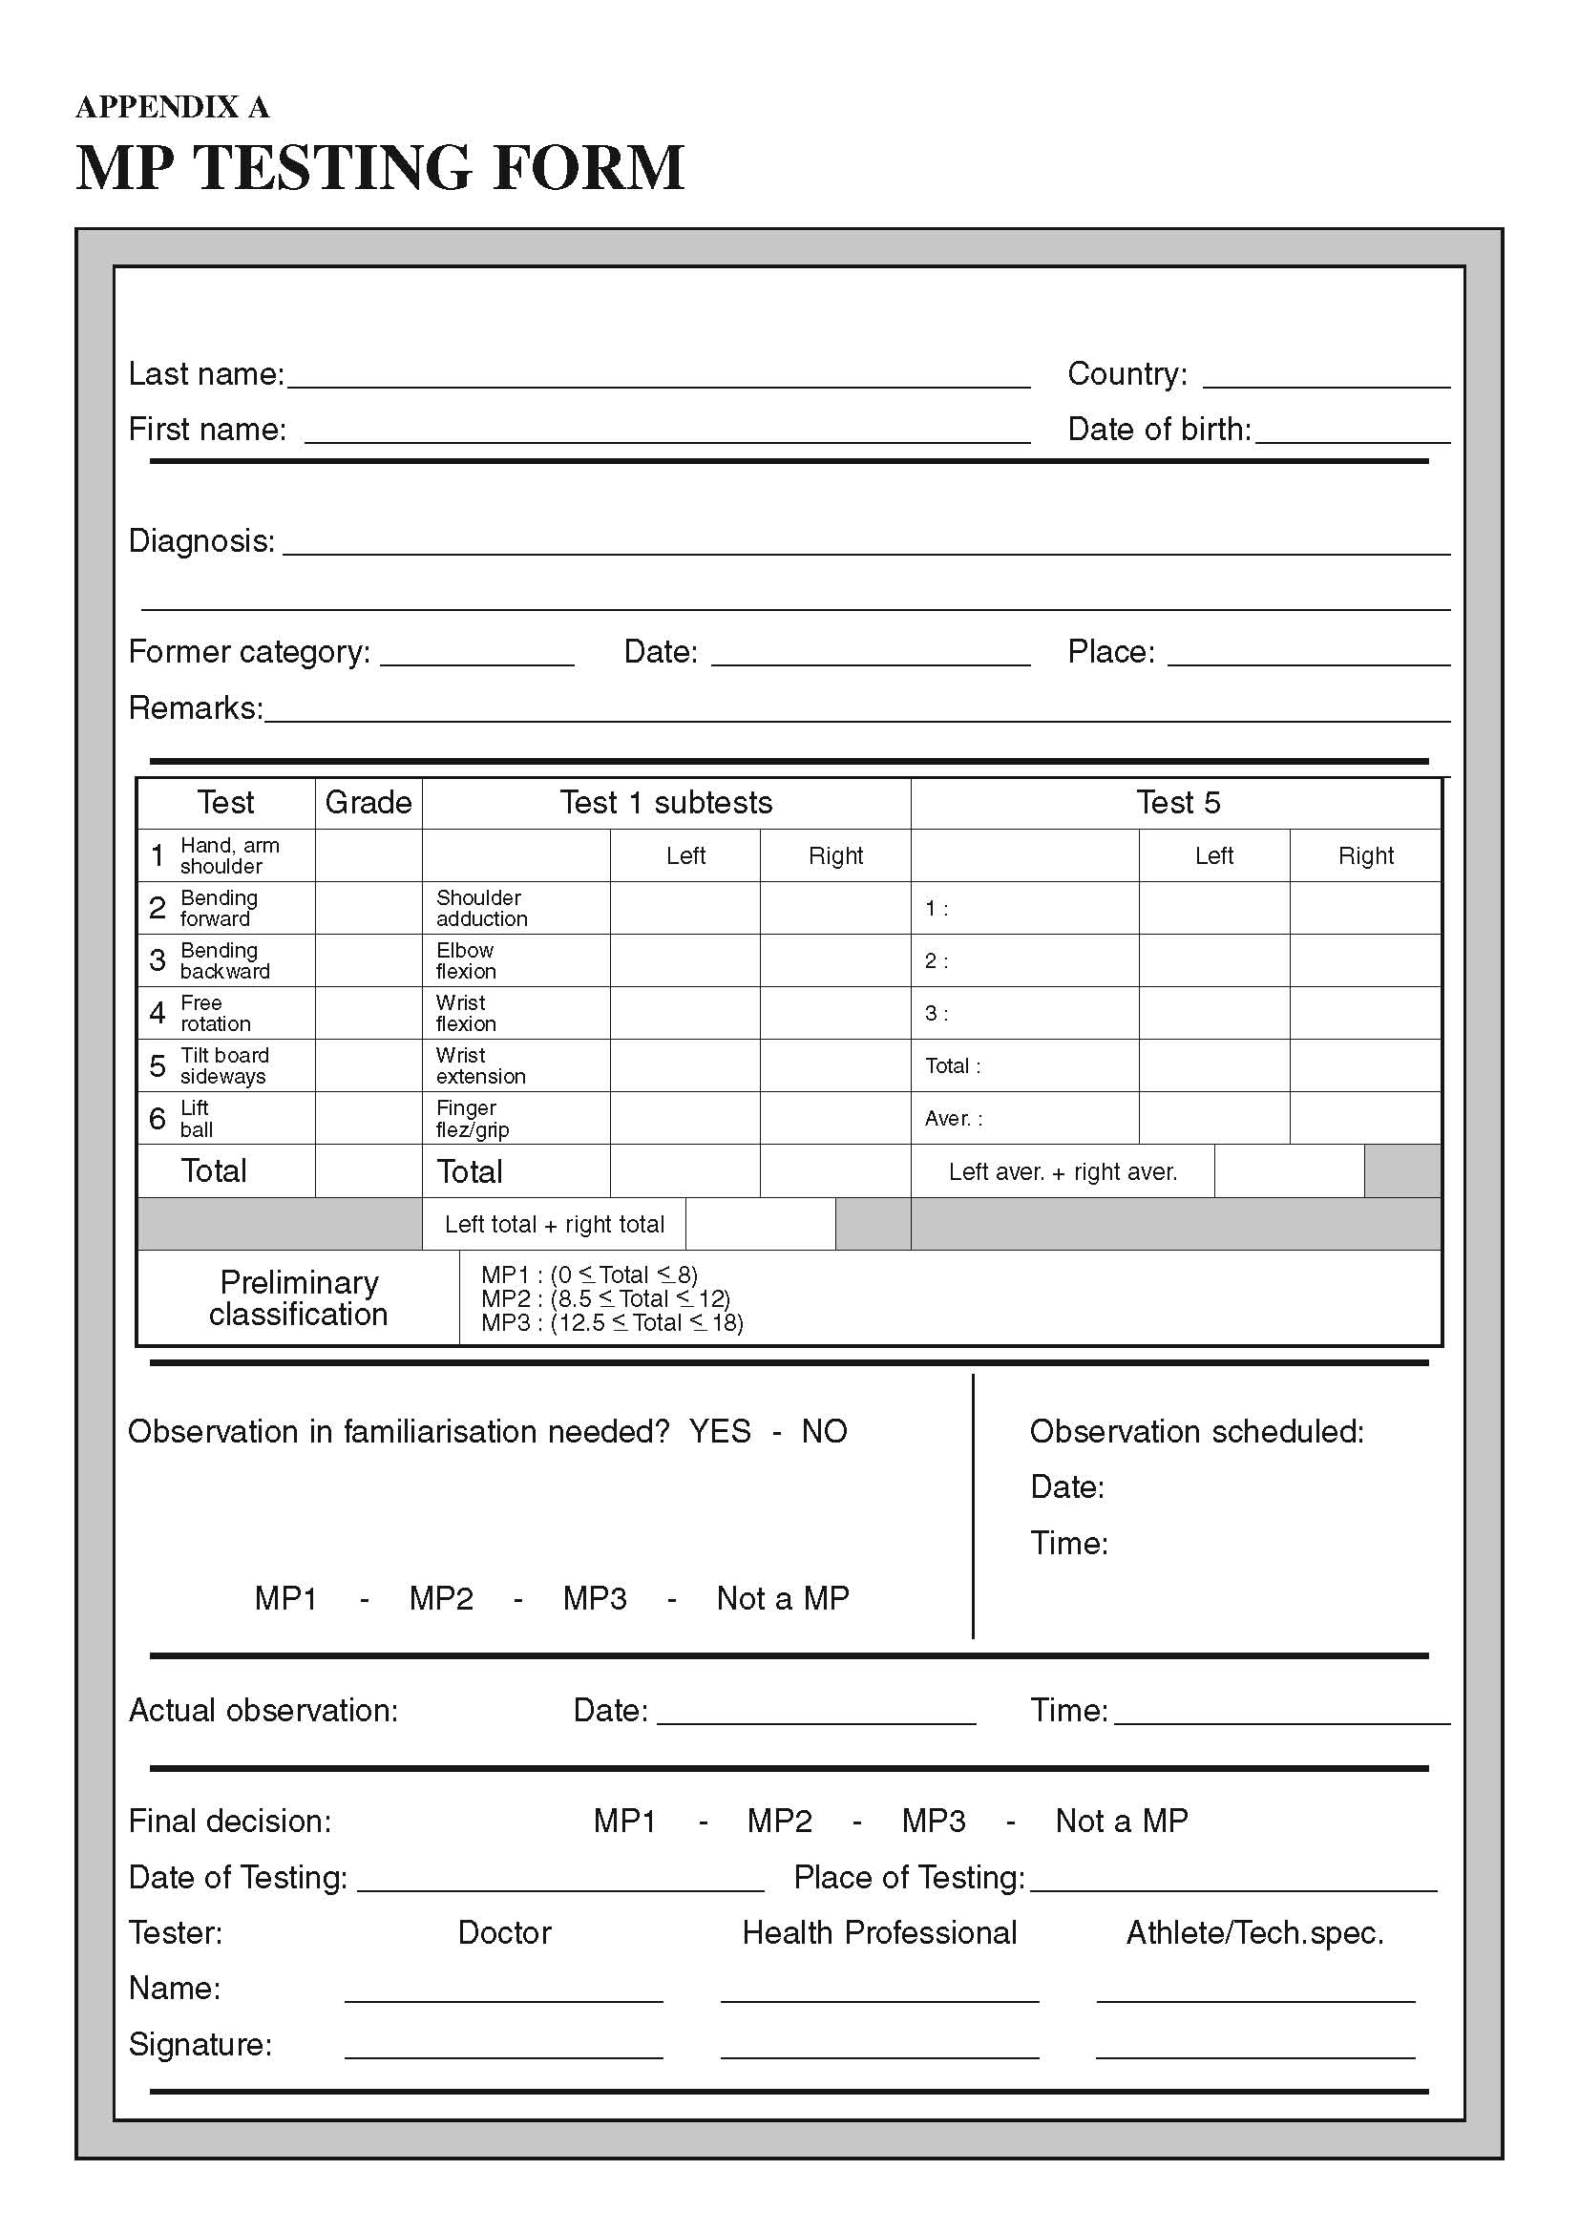
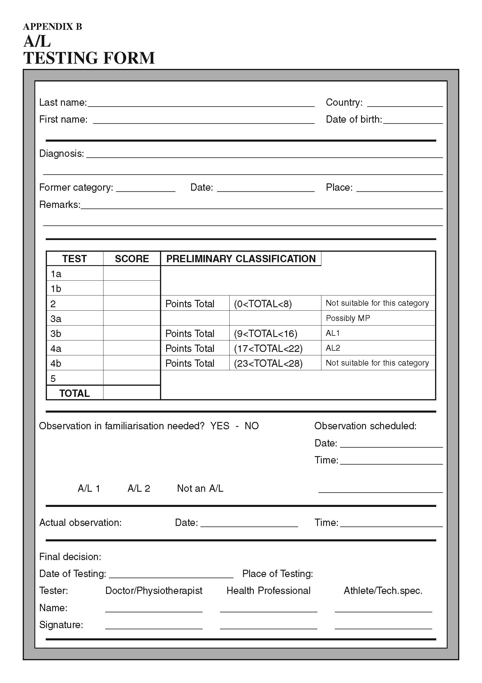
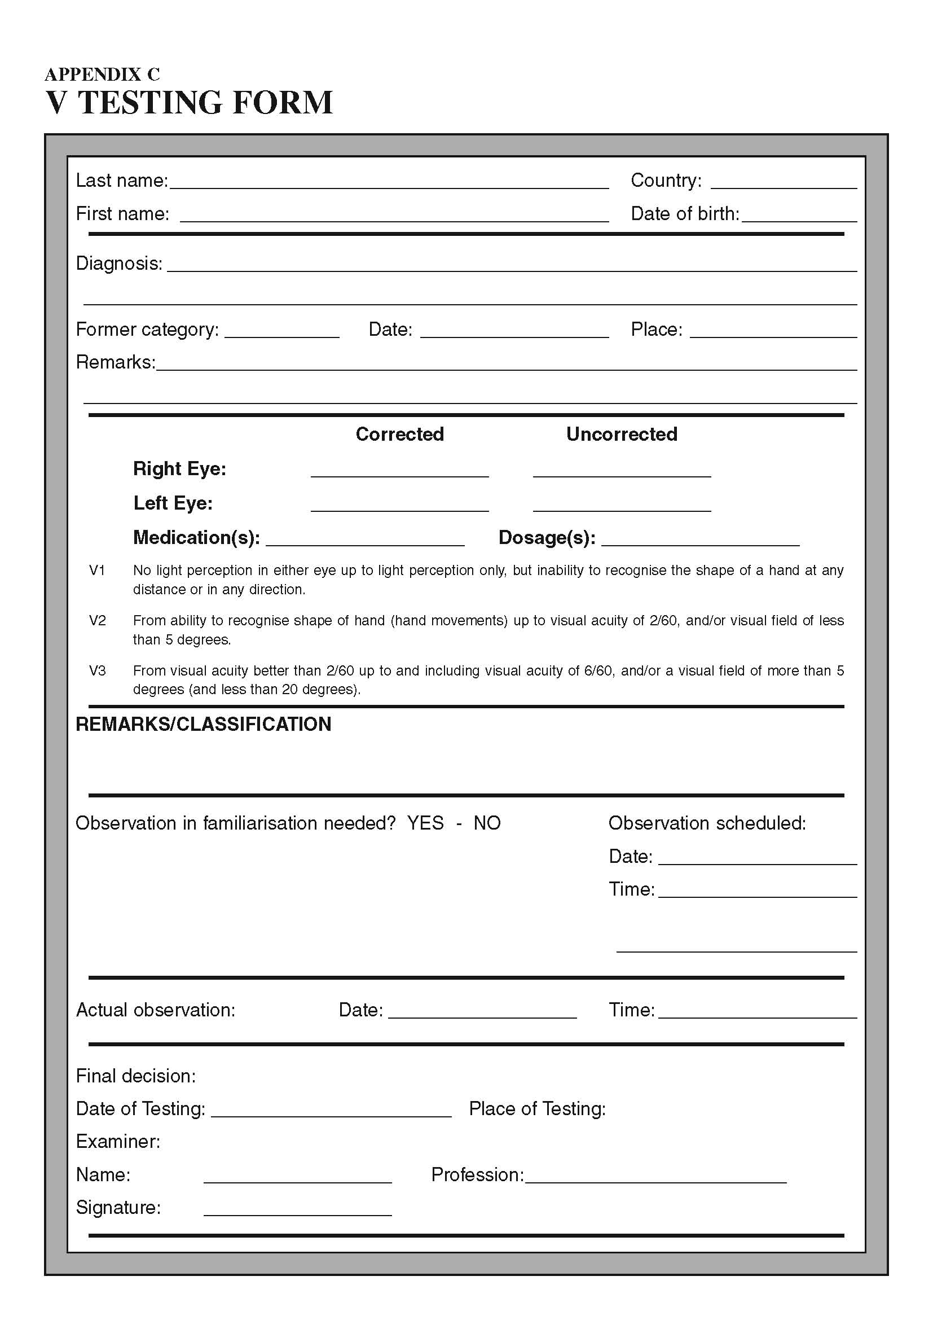

appendix D – MP Familiarisation Guidelines Form

Skier Name: Date:
Classification in land based test: Final Decision:
Signed:
(Classification Chief)

Water Ski Activity | MP1 | MP2 | MP3
Pull out of Water | NO use of trunk | Minimal use of trunk | Maximum use of trunk  Can lean back
Hand Function | Uses wrist(s) or forearms to hold handle.  May or may not release while turning | Holds handle but may have weakness in one/both hands.  Adequate grip strength to hold handle in palm of the hand. | Holds handle with full strength in both hands.
SLALOM | Unable to use abdominals, trunk extensors to pull in or take slack from rope.  May use arm movements to manage slack. Skier will rest trunk on knees. | Limited use of trunk.  Primarily use head and upper trunk movements. | Full use of trunk musculature to maintain balance.  May use trunk to pressure ski fore/aft.
Slalom Direction Changes | Unable to lift chest from knees.  Tends to stabilize by holding cage with one arm/wrist while turning or crossing wake. May steer with head and upper shoulders. | Primarily use head, shoulders and upper trunk to change edges (direction.)  May lift head and shoulders from knees. May stabilize by holding onto cage with one hand. | Use head and maximal musculature trunk to change edge (direction.)  May stabilize by holding cage but not necessary to maintain balance.
JUMP | Tend to stay forward on knees and is unable to lift body from knees without using arm strength. Head and neck movement only.  Maintains edge angle using head and arm position only. | May extend head and upper trunk.  Maintains edge angle using head, shoulders and upper trunk musculature. | May fully extend trunk actively if necessary.  Maintains edge angle using maximal amount of trunk musculature.
Jump Landings | Tend to lock onto cage with forearms and elbows.  No compensation with trunk musculature for correction. | Hold cage with one hand or lock with forearms and elbows.  Able to compensate minimally with trunk to correct landings. | May or may not hold cage at landing.  Significant use of trunk musculature to correct landings..
TRICK | Trunk stays forward on knees.  May hang onto cage for stabilization. | Head and shoulders may be extended to initiate movements.  May hang onto cage for stabilization. | May lift trunk from maximally.  May not need to stabilize with arms. Able to advance rope by using abdominals in conjunction with arms.

Appendix E – Testing Board Diagram

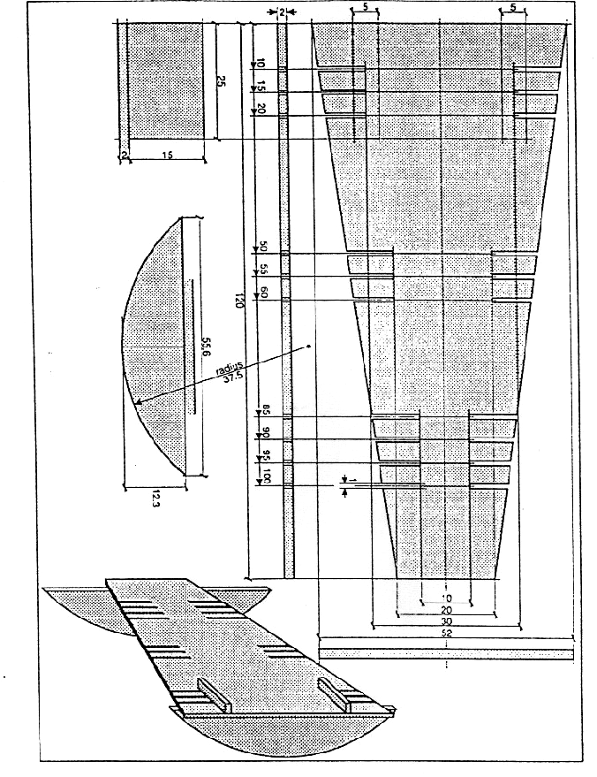

Appendix F1 – The Skeletal System

Appendix F2 – The Dermatomes of the Body
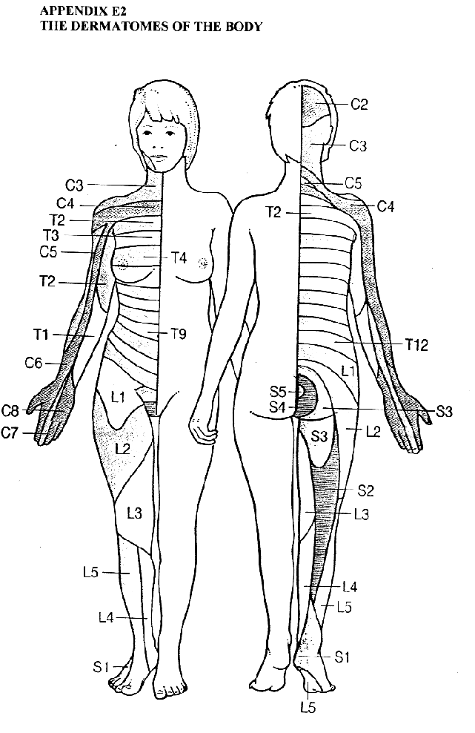

Appendix F3 – Functional Activity for Spinal Cord Injuries
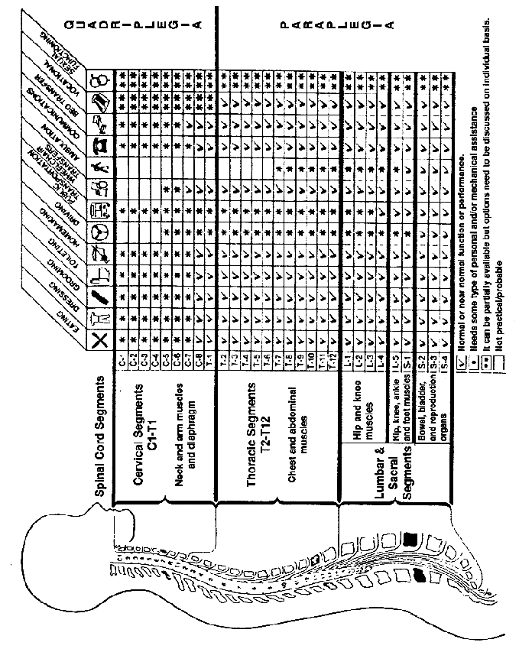

Appendix G – Cross Section of the Human Eye/ Light Transmission to the Brain


