WWC
Cable Wakeboard World Championships 2006

26th to 30th of July

Feldkirchen an der Donau
AUSTRIA

Bulletin N° 2

Held by:

- ÖWSV – Austrian Waterski Federation Organization, Marketing & PR:

- Wakeboard Club Feldkirchen k-quadrat Eventmanagement
Anzing 8
4113 St. Martin
AUSTRIA

Contact

Stefan Kastner +43 699 1910 1979
Michael Krikula +43 699 1938 3819
Wolfgang Scheibner +43 699 1632 3214

Email officekastner@resi.at
michael@snowboard.at
wolfgang@jetlake.com

Telefax +43-7232-2846-20

Web www.wakeboard.ag

Dear wakeboarders
and friends of board sports,

After two successful years with the EAME Cable Championships in 2004 and the ONE Wakeboard Open in 2005 it’s a pleasure for us to welcome you at the

WWC Cable Wakeboard World Championships 2006

sponsored by: ONE, NOKIA, PROTEST
held in commission and with permit of the Austrian Waterski Federation (ÖWSV) and the district of Upper Austria in Feldkirchen, next to Linz.

Date: 26th to 30th of July 2006
Place: jetlake Cable Feldkirchen / Austria

After the great success from the last two years we are still motivated to improve our event and trying to organize the biggest Cable Wakeboard Worlds ever seen. Once again we would be very glad to welcome the best cable riders from all over the world. Therefore Stefan Kastner totally rebuilt his jetlake cable park:
- New molded seating arena on the beach
- The cable got 1,5 meters higher
- New side-event areas were formed with new beach volleyball, Wake Trainer, FMX hill, …
- New 18 Meter long Flat Box
We are looking forward to see all of you at the jetlake in Feldkirchen!

Important NEWS in Bulletin 2
1. Obstacles - provisional setup Page 03
4. Entry Fee – Bank Details Page 05
6. Drug Tests Page 05
8. Training Page 06
9. Judge Panel Page 06
14. Obstacle Competition on Sunday Page 08
17. TV-Distribution Page 09
18. Summary of Intentions to Enter Page 10
Entry Form Page 11-12

1. Location

Feldkirchen is 20 minutes northwest from Linz (Austria’s biggest city after capital Vienna).
The recreation area, which is spread around five swimming lakes in Feldkirchen next to the Danube, has a magnetic effect on thousands of sun-bathers during the summer. In 2000 the company jetlake built the necessary infrastructure to transform the facility around the cable-lake to a communications hot spot for all sport freaks. The Austrian Wakeboard scene received new and unique impacts. The cable-facility represents a wonderful platform for training as well as international contests.

Cable
Jetlake, well known after the last two years, is situated on a lake in a beautiful green landscape next to the river Danube. It’s a Rixen cableway 4 mast system. New Height 10.1 Meters to 10.4 Meters.

Obstacles
- Rainbow Slider
- Kicker
- Funbox with A-Frame Slider and Wallride
- NEW 18 Meter Flat Box, 1 Meter width

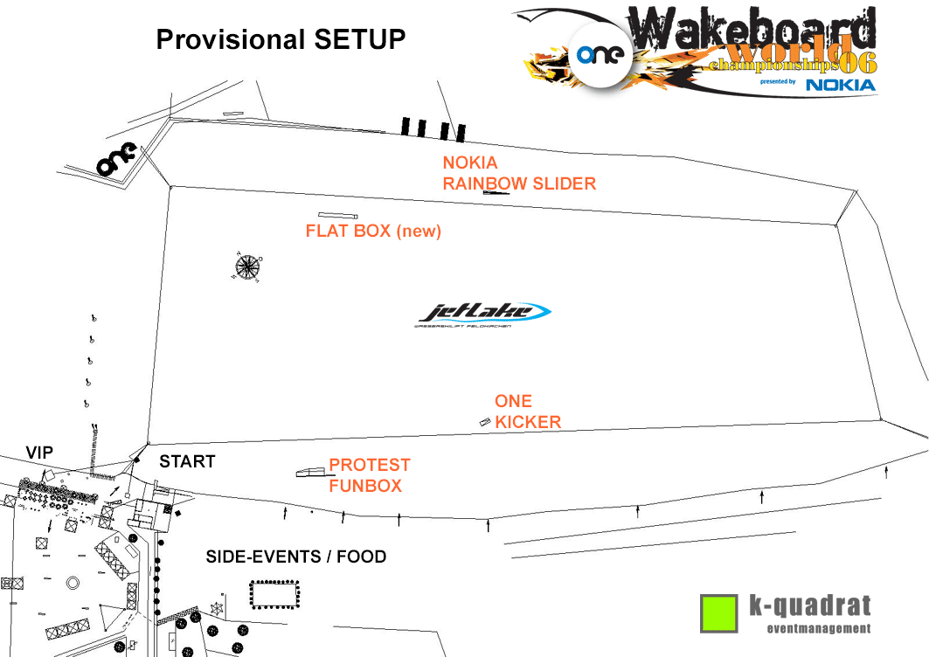

2. How to get there

2.1. By car:
- A1 to “Knoten Linz” change to A7 direction Linz
- Pass Linz and take exit Linz Urfahr
- Take B 127 direction “Rohrbach”
- Always direction “Rohrbach” till you reach Ottensheim
- Take the second turn on the left after the robot (traffic lights) direction “Feldkirchner Badeseen”
- Always straight about 11 km till the sign “Wasserskilift”
- Follow our signs, you almost made it

2.2. By plane:
Best arrive at Linz-Hörsching airport
You can also arrive in Vienna or Salzburg airport (both about 2 hours by car)

2.3. By train:
Straight to „Linz Hauptbahnhof”

Shuttle:
We arrange a direct transport by minibus from airport Linz-Hörsching and railway station
Linz-Hauptbahnhof (Mainstation). Please inform us as soon as possible about your arrivals. Shuttle transport is only possible in teams.
During the competition a shuttle transport picks you up in the morning and brings you back in the evening. Times will be announced on the site.

3. Goodies for the riders
- Free camping area for riders only on the site, toilets, cold shower and Sauna
- Whirlpool on the starting dock
- Special Riders area by Red Bull to make your stay as comfortable as possible
- Drinks and 2 Meals per day during the competition
- Physiotherapist and masseur for riders only
- Free entrance to the concerts and parties on Thursday, Friday and Saturday

4. Entry
4.1. Entry Fee
Juniors and Boys/Girls 100,oo Euro/person
Open Men/Women and Masters 130,oo Euro/person

The entry fee must be paid cash in Euro latest when you registrate at the competition venue
or in advance via bank transfer:
Bank: Oberbank AG
Bank Number: 15013
Account Number: 04041027188
IBAN: AT021501304041027188
BIC: OBKLAT2L

4.2. Nomination & entry
It is in the responsibilty of the National Federations to nominate their riders.
Official registration form on page 11-12.

4.3. Competition venue
jetlake Felkirchen
Badeseestrasse 6
4101 Feldkirchen
Austria

4.4. Conditions
The WWC Cable Wakeboard World Championships 2006 will be carried out according to the
IWSF World Cable Wakeboard Commission. A full copy of the rules will be available on: www.cablewakeboard.com

5. License
All riders should be members of their respective country’s IWSF affiliated Federation.

6. Drug Tests
We have to inform you about the possibility of dopping tests in all categories held by the international drug comitee.

7. Categories
A rider's age as of 1st. January 2006 of the current year will be used to determine age bracket.
If a rider was born in the following years, then they qualify for this category:
Boys 1991 and after
Girls 1991 and after
Junior Men 1990 - 1989 - 1988 - 1987
Junior Ladies 1990 - 1989 - 1988 - 1987
Open Men No age restriction
Open Ladies No age restriction
Masters Men 1975 or before
Masters Ladies 1975 or before

8. Training
Wednesday, July the 26th
- Official training in teams/groups, no payment
- Official Training lasts from 8:00 am to 7:00 pm
- We have to put together always 15 persons per hour
Please send an Email with the time your team wishes to train latest until 14th of July to Wolfgang Scheibner. Teams that don’t make a wish right in time get scheduled by the organizer.
Further training is possible against payment on Monday, 24th and Tuesday 25th upon request.
9. Judge panel
Chief judge: Harry Sedlmayr - Germany
Chief judge Assistant: Robert Gattringer - Austria
Judges:
- Mihovil Brebic Croatia
- Nicole Freeman Great Britain
- Gyuri Kirsch Hungary
- Lu Le U.S.A.
- Florian Meeh Germany
- Alex Peschel U.S.A.
- Peter Wilkings Australia
- T B A
- T B A
Chief scorer: Stephan Freeman - Great Britain
Chief scorer Assistant: Bianca Wolfmayr - Austria
Jetty Marshall: Phillip Gubo - Austria

10. Accommodation

8.1. Bed & Breakfast
We managed several bed and breakfast accommodations in Feldkirchen for an average price (about 23 Euros/night) in distances from 1 to 10 km from the cableway. A free shuttle bus will take you daily to the site in the morning and bring you back in the evening/night. Schedules will be posted at the cable way stop and on the stops next to your accommodation.
Please notice, that some bed & breakfast don’t accept credit cards.
8.2. Camping
As mentioned before we arranged a riders only camping area next to the cableway, which is a little bigger than it’s used to be in 2004 and 2005, including cold shower and toilet. This is a closed area that riders only are allowed to stay. We will collect a fee of 10 Euros/person for garbage for the whole duration of the event.
Attention: There’s only space for a limited number of 60 tents. Please contact us in time.
For your friends and families there is the possibility of staying at the official camping ground, which is only about 5 min away from the cable way.
Please notice: The organizer is not responsible for any stolen or damaged equipment in or outside the whole event area, including also the riders area.

8.3. Reservation
Please contact Wolfgang Scheibner for any kind of accommodation:
wolfgang@jetlake.com or +43 699 1632 3214
The first reservations will get the best rooms or a place at the camping area.

11. Rental Cars

EUROPCAR – www.arac.at
Austrian Service Center: reservations@europcar.at
Tel.: +43 1/8661633, Fax: +43 1 8693714
VIENNA Airport Schwechat: viet01@europcar.at
Tel.: +43 1/7007 326 99, Fax: +43 1 7007 336 42
LINZ Airport Hörsching: lnzt01@europcar.at
Tel.: +43 7221/600 63 12, Fax: +43 732 772529
AVIS - www.avis.at
VIENNA Airport Schwechat: Tel.: +43 1 7007 32700
LINZ Airport Hoersching: Tel.: +43 72216006300

SIXT GmbH - www.sixt.com
Hotline: +43 800 1111 7498
BUDGET - www.budget.at
International Reservations: office@Budget.at
+43 (0) 7242-77774-16

12. Party & Side Events
International live-acts will show up performing reggae, ska, punk, Hip Hop and alternative music. In the last years we had up to 10.000 spectators and this year won’t be less.
Party Schedule
Wednesday: Official Opening Ceremony
Thursday: Welcome Riders Party
„Whatever DJ Sound” with ragga, dancehall, ska and punk vibes.
Friday: Big Boarder Party with Radio FM4, Whatever Sounds and international live acts.
Saturday: Big Boarder Party with Radio FM4, Whatever Sounds, live acts and FMX Show.
Check out our Website www.wakeboard.AG for further details on live-acts!

13. Boat Jam Session
As the years before we will run the Boat Jam Session, with some of the best riders from all over the world, to demonstrate Wakeboarding behind the boat. Therefore we got the brandnew Mastercraft X2 towboat. About 10 Riders will get an invitation to perform on Friday and Saturday evening after the cable comp and on Sunday noon.
If you think, that you are the men to perform at this Jam Session, please write us an E-Mail.

14. Obstacle Competition on Sunday
To demonstrate Cable Wakeboarding at its best, we are going to run a special obstacle competition on Sunday. Nice price guaranteed!

15. Official Homepage

Check out www.wakeboard.AG Magazine with the latest Wakeboard News around the world.
This, Platform and Communication Board will host the official Homepage for the Cable Worlds 2006.

16. Timetable (provisional)

Wednesday, July 26th
08:00 to 19:00 Official Training
19:00 Team captain meeting
20:00 Opening Ceremony

Thursday, July 27th
09:00 Riders meeting
10:00 Start Qualification all categories
21:00 Boarders Welcome Party

Friday, July 28th
09:00 Continuation with Qualifications
11:00 LCQs all categories
16:00 Start Semifinals Open Men and Junior Men
Press Conference and Wakeboard Show
Riders presentation
19:00 Boat Jam Session
21:00 Boarder Party, DJ Sessions + Live acts

Saturday, July 29th
09:00 Continuation Semi Finals
13:00 Finals
Side Events for the crowd
19:00 Boot Jam Session and TV-Interviews with all winners
20:00 Prize giving ceremony
21:00 Boarder Party, DJ Sessions + Live acts

Sunday, July 30th
Reserve day
11:00 Boat Jam Session
Pro Wakeboard Show
Obstacle Competition
15:00 Chill out
17:00 End

17. TV Distribution
For this World Championships we work together with a big international TV-Distribution company, spreading free Material to any kind of TV-Stations and Formats.
The production includes:
- NEWS on Sunday morning
- Rough Cut 30 minutes on Sunday morning
- 24 minutes finished Highlight production in German and English 5 days after the event
If you stay in contact or know some channels or formats that need TV-Material. For additional distribution please contact Michael Krikula as soon as possible.

18. Summary of Intentions to Enter
Till now we got official Intentions from 15 federations:
AUS, AUT, BUL, CRO, FRA, GBR, GER, ISR, HUN, NED, PHI, RSA, SER, SLO, USA,
We are optimistic to have up to 2 or 3 more federations from Europe. Also we think of having more Asian countries with us.
Fixed Age categories:
Men: Men Open Men (40+), Junior Men (40+), Boys (20+), Masters men (20)
Women: Open Ladies (8 today), Junior Ladies (6 today), Girls (8 today)
For the first time Masters Ladies category could be opened.

19. Contact

Organisation:
Stefan Kastner - Cable owner +43 699 1910 1979 officekastner@resi.at
Michael Krikula - Press & Rider Coordination +43 699 1938 3819 michael@snowboard.at
Wolfgang Scheibner – Accommodation, Entry +43 699 1632 3214 wolfgang@jetlake.com

Telefax +43-7232-2846-20
Web www.wakeboard.ag

Contact WWC Cable Wakeboard Council
Chairman Hans Otte
Treskowallee 86
D 10318 Berlin
Germany
Phone: +49 30 508 2264
Fax: +49 30 503 821 90
e-mail: wakeboard-otte-berlin@t-online.de

Looking forward to ride with you.
Please inform us about your participation as soon as possible.
If you need help, please feel free to contact us!!!

WWC Cable Wakeboard World Championships 2006

26th to 30th of July - Feldkirchen an der Donau / AUSTRIA

ENTRY FORM
TO BE SUBMITTED BY 16 JULY 2006

The ____________________________ Federation enters the following riders:

No. | Family name | first name | sex (m, f) | Category | date of birth | ∗
1
2
3
4
5
6
7
8
9
10
11
12
13
14
15
16


TEAM CAPTAIN: ________________________________________

The undersigned Federation Official certifies, that the information listed above is true and that the registered riders are in possession of a wakeboard license and a valid insurance, and relieves the organizer, the organizing Federation, the officials and the IWSF of any responsibility for any accident, which could occur to the riders during the competition and training.

Name of Federation official: ____________________
Position in Federation: ________________________
Phone: ___________________
E-Mail: ___________________

Date Signature of Federation official

Please send this form latest by 16 July, 2006 to the organizer and to the World Cable Wakeboard Commission. See contacts bellow!
For entries received after 16th July 2006 a penalty will be applied per day and rider as per IWSF Bye-laws 15.2.4

CONTACTS:
Organizer: World Cable Wakeboard Commission:

Mr. Wolfgang Scheibner Mr. Hans Otte
E-Mail: wolfgang@jetlake.com E-Mail: Wakeboard-Otte-Berlin@t-online.de
Telefax: +43-7232-2846-20 Telefax: +49 30 50 38 21 90
Phone: +43 699 1632 3214 Phone: +49 30 50 82 264
Adress: Anzing 33 mobile: +49 172 3001340
4113 St. Martin
Austria

For further details please check out the official homepage www.wakeboard.ag

