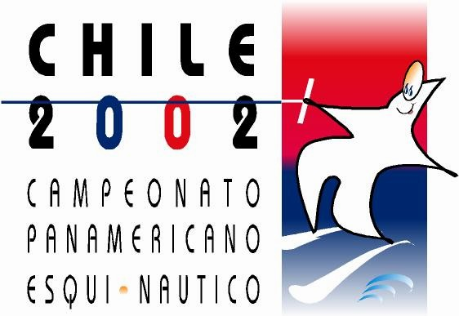

PANAMERICAN CHAMPIONSHIPS

SANTIAGO-CHILE

NOVEMBER 27 – DECEMBER 1, 2002

Bulletin 2
Below, please find the Officials and the Official Schedule for the PanAm Championships to be held in Chile

Chief Judge: Pat Carrol Canada
Ast. Chief Judge: Waldo Miranda Chile
Chief Boat Driver: Ernesto Revilla Argentina
Drivers: Kyle Oberdorf Canada
Francisco Farías Chile
Gary Manhel USA
Chief Calculator: Adiena Loewen Canada
Scorer: Leon Larson
Homologator: Luis Gisler Argentina
Judges: Edgardo martín Argentina
Sherm Schraft USA
Nikki Lee USA
Steve Gosse Canada
Jorge Font Mexico
Camilo Espinel Colombia
Jorge Renosto Argentina

Schedule
Monday Nov. 25 Training

Tuesday Nov. 26 training

Wednesday Nov. 27 Homologation 08:00 – 12:00
Welcome Cocktail 12:00 hrs.
Senior Women Tricks semi finals 14:00 hrs.
Senior Men Tricks semi finals
Junior women Tricks semi finals

Thursday Nov. 28 Sub 21 Women Tricks semi finals 09:00 hrs.
Junior Men Tricks semi finals
Sub 21 Men Tricks semi finals
Open Women Tricks semi finals
Open Men Tricks semi finals

Senior Women Slalom Semi finals 15:00 hrs.
Senior Men Slalom Semi finals
Junior Women Slalom Semi finals

Friday Nov. 29 Sub 21 Women Slalom Semi finals 09:00 hrs.
Junior Men Slalom Semi finals
Sub 21 Men Slalom Semi finals
Open Women Slalom Semi finals
Open Men Slalom Semi finals

Senior Women Jump semi finals 15:00 hrs.
Senior Men Jump semi finals
Junior Women Jump semi finals
Sub 21 Women Jump semi finals

Saturday Nov. 30 Junior Men Jump semi finals 09:00 hrs.
Open Women Jump semi finals
Sub 21 Men Jump semi finals
Open Men Jump semi finals

Senior Women Slalom Finals 13:00 hrs.
Senior Men Slalom Finals
Junior Women Slalom Finals
Sub 21 Women Slalom Finals
Junior Men Slalom Finals
Sub 21 Men Slalom Finals
Open Women Slalom Finals
Open Men Slalom Finals

Sunday Dic. 01 Senior Women Tricks Finals 09:00 hrs.
Senior Men Tricks Finals
Junior Women Tricks Finals
Sub 21 Women Tricks Finals
Junior Men Tricks Finals
Sub 21 Men Tricks Finals
Open Women Tricks Finals
Open Men Tricks Finals

Senior Women Jump Finals 13:00 hrs.
Senior Men Jump Finals
Junior Women Jump Finals
Sub 21 Women Jump Finals
Junior Men Jump Finals
Sub 21 Men Jump Finals
Open Women Jump Finals
Open Men Jump Finals

Closing ceremony 21:00

