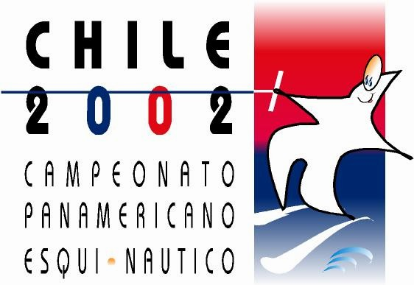

PANAMERICAN CHAMPIONSHIPS

SANTIAGO-CHILE

NOVEMBER 27 – DECEMBER 1, 2002

CURRICULUM VITAE

Deadline 30 October 2002

Name _____________________ First Name ______________________

Date of Birth _____/_____/_____ Sex ______________

Nationality __________________

BEST PLACEMENTS

SLALOM

TRICKS

JUMP

BEST PERFORMANCES

SLALOM_______________ TRICKS_______________ JUMP_______________

