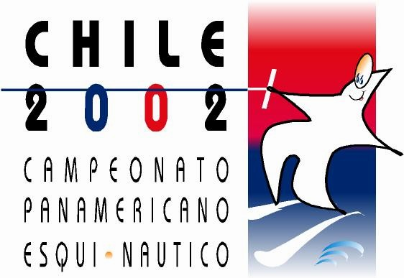

PANAMERICAN CHAMPIONSHIPS

SANTIAGO-CHILE

NOVEMBER 27 – DECEMBER 1, 2002

Make a cross on the corresponding square.

Team Member: Judge: Driver:

- Team /Person`s Name: _________________________________________
- Total number of people: _________________________________________
- Date and time of arrival: _________________________________________
- Airline: _________________________________________
- Date and time of departure: _________________________________________

______________________________________________________________________
Note:
It is very important that this form to be returned not later than November 30, 2002 in order to arrange the vehicles which will be waiting for you at the airport.
Please return by fax or e-mail to the Chile Water Ski Federation.
Fax: 56-2-6458178
Phone: 56-2-6432519
E-mail: fedeesqui@sanpablosa.cl

