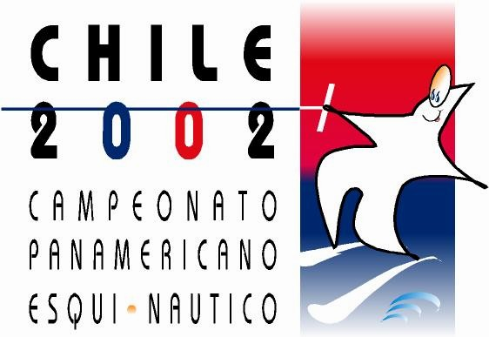

PANAMERICAN CHAMPIONSHIPS

SANTIAGO-CHILE

NOVEMBER 27 – DECEMBER 1, 2002

INTENTION TO ENTER

TO BE SENT WITHIN 30 SEPTEMBER 2002

THE __________________________________ FEDERATION

Intends to enter a Team to the 2002 PanAmerican Water Ski Championships

We extect our team to consist of:

n. _____________ male skiers

n. _____________ female skiers

n- _____________ individuals

n. _____________ Team Officials

Please return this form back to:

CHILEAN WATER SKI FEDERATION, FAX: 56-2-6458178
E-MAIL: fedeesqui@sanpablosa.cl

