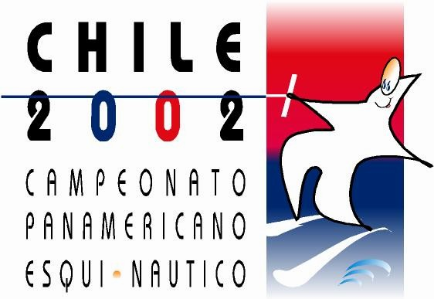

PANAMERICAN CHAMPIONSHIPS

SANTIAGO-CHILE

NOVEMBER 27 – DECEMBER 1, 2002

PANAMERICAN WATERSKI CHAMPIONSHIPS

OFFICIAL ENTRY

DEADLINE: 30 OCTOBER 2002

COUNTRY/FEDERATION

Phone fax e-mail

TEAM MEMBERS
Qualifing Scores

 | Name | Date of birth | sex | Slalom | tricks | Jump | Ramp hight
1
2
3
4
5
6

 | Name | Date of birth | sex | Slalom | tricks | Jump | Ramp hight
7
8
9
10
11
12

RESERVE SKIERS

 | Name | Date of birth | sex | Slalom | tricks | Jump | Ramp hight
1
2
3
4

I certify that the information listed above is true and the registered skiers are in possesion of a skiing licence and a valid licence and relieve the Organizing Federation, The officials and IWSF of any responsibility.

Name of the President Federation: _______________________________________

Signature: __________________________ Date: _________________

