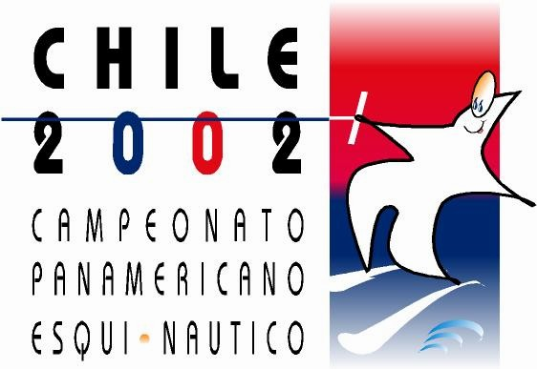

PANAMERICAN CHAMPIONSHIPS

SANTIAGO-CHILE

NOVEMBER 27 – DECEMBER 1, 2002

APPLICATION FORM
FOR CREDITING

TEAM CAPTAIN

TEAM OFFICIAL

TEAM STAFF

NAME ______________________ FIRT NAME ______________________

NATIONALITY __________________ SEX ____________________________

PLEASE RETURN THIS FORM THE CHILEAN WATER SKI FEDERATION NO LATER THAN 30 OCTOBER 2002.

